YOU MUST HAVE AN ACTIVENET ACCOUNT TO RESERVE A SITE!
When you are on the Mound View Park website, click on the HERE highlighted in red. (See below) 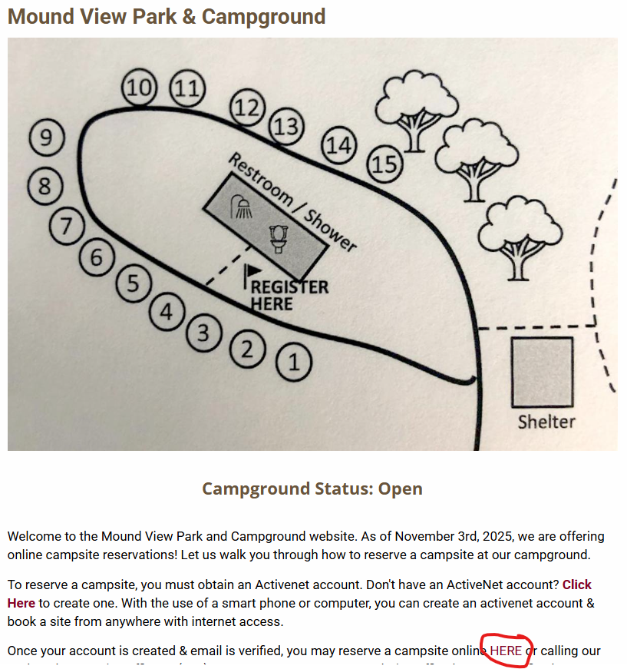

Once clicked, that link will take you to the popular events booking page. (see below)
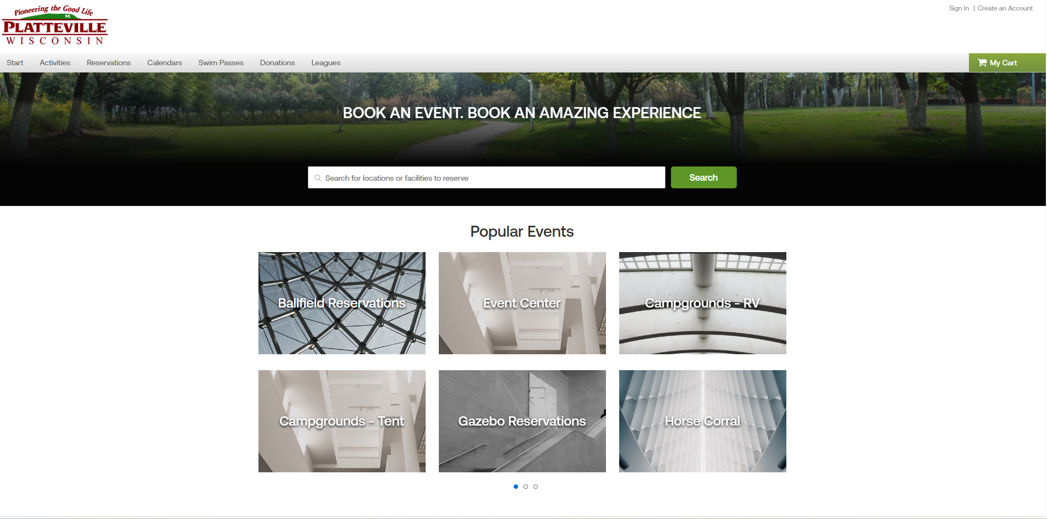

Choose Campground RV, to view RV sites OR Campground Tent to view tent sites. (see below)
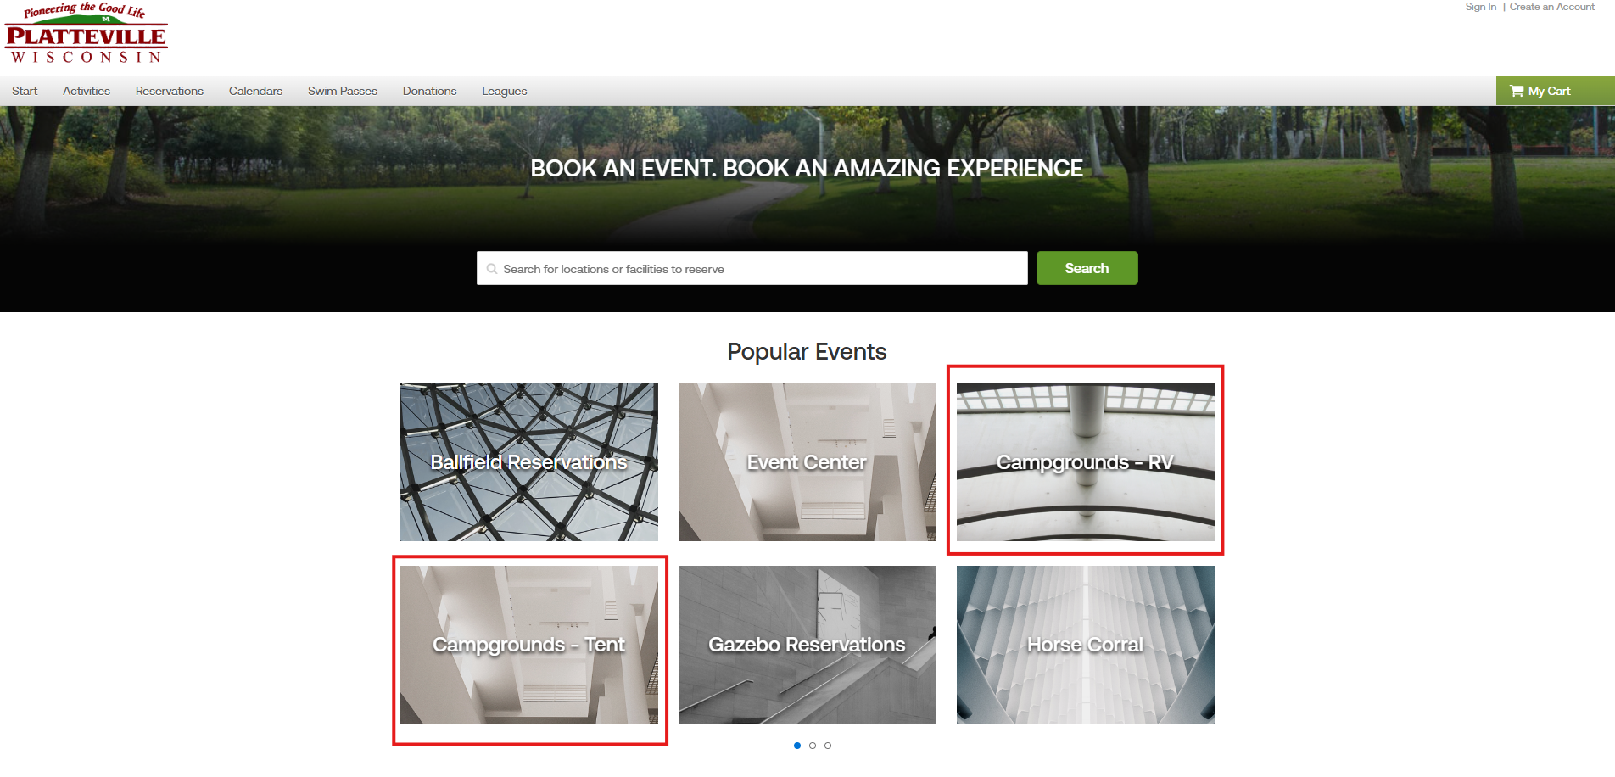

Once you select Campground RV or Campground Tent, it will take you to the site selection page. (See below)
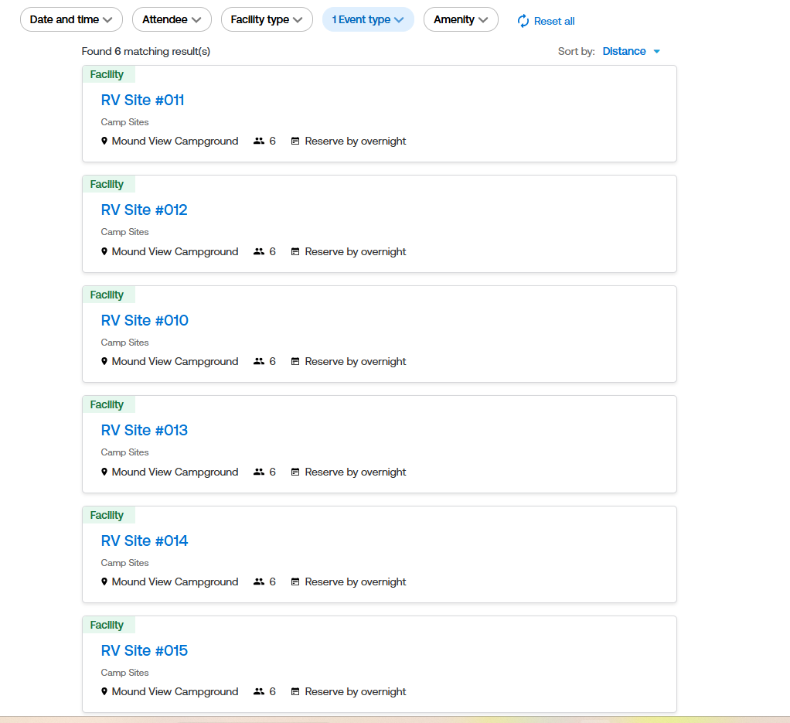
Select any site that you would like from that list!
Once selected, it will open the individual site page. (See below)
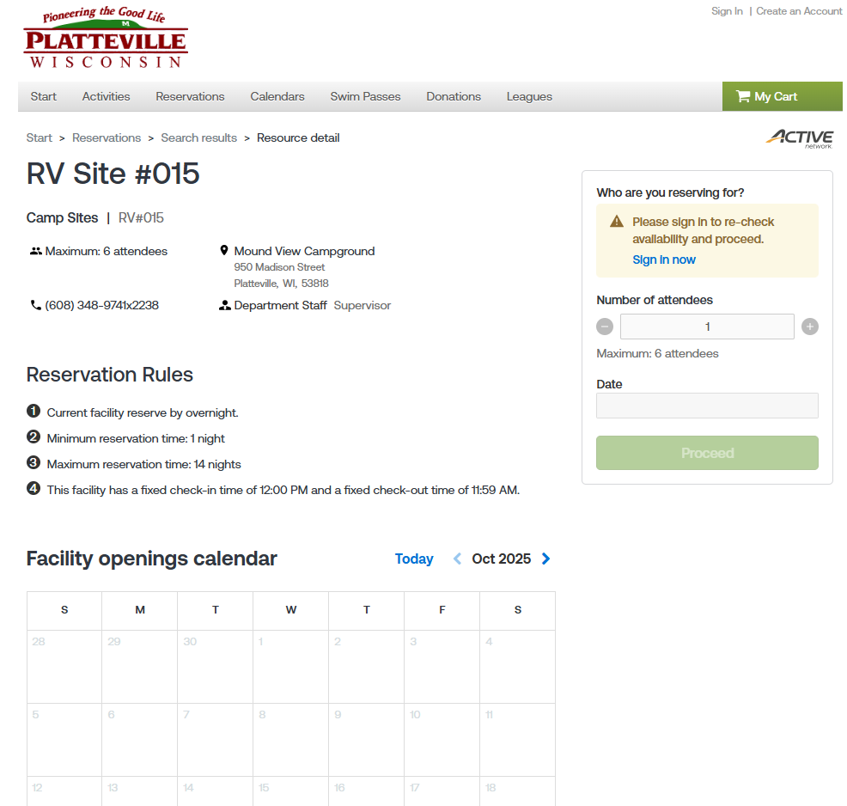
At the bottom of the site page, you may view the Facility Openings Calendar. That will display the availability for the season!

Scroll through the Facility openings calendar until you see the date range you would like to stay. Once you see the date, select your arrival date & departure date. (see below)
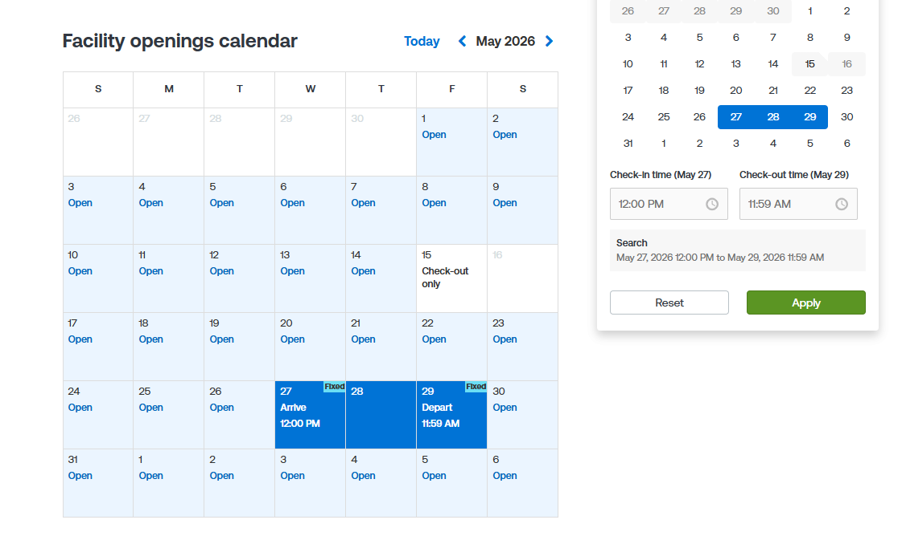
Once Selected, push Apply to move to the next page!

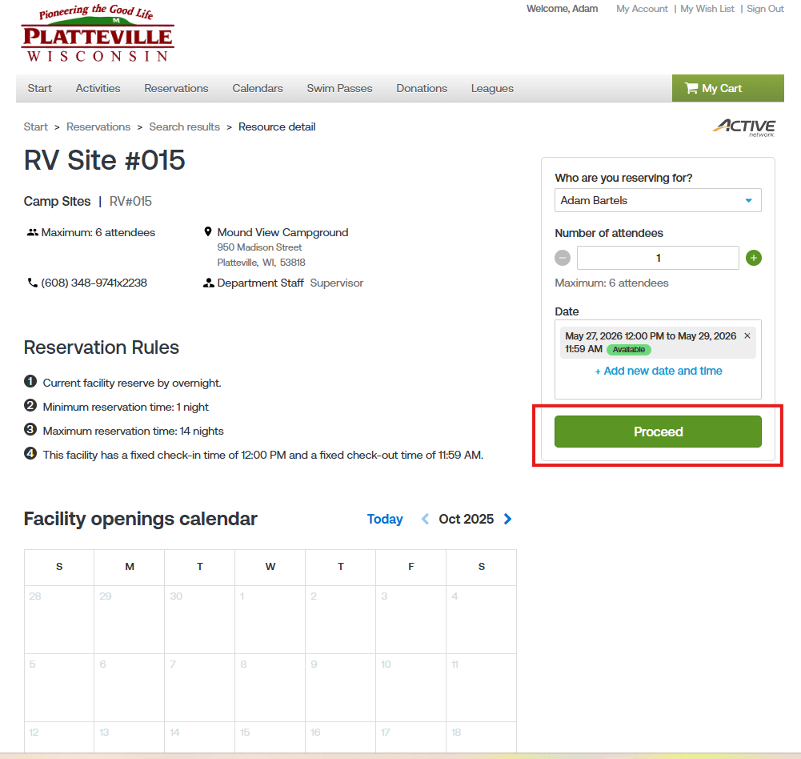
Once you have applied, push proceed to move onto the final booking pages. (see below)

Once you select proceed, you will need to enter an event name (your last name) and select an event type (campgrounds RV or Campgrounds Tent). Once selected you will need to answer some custom questions and agree two a couple of waivers. (see below)
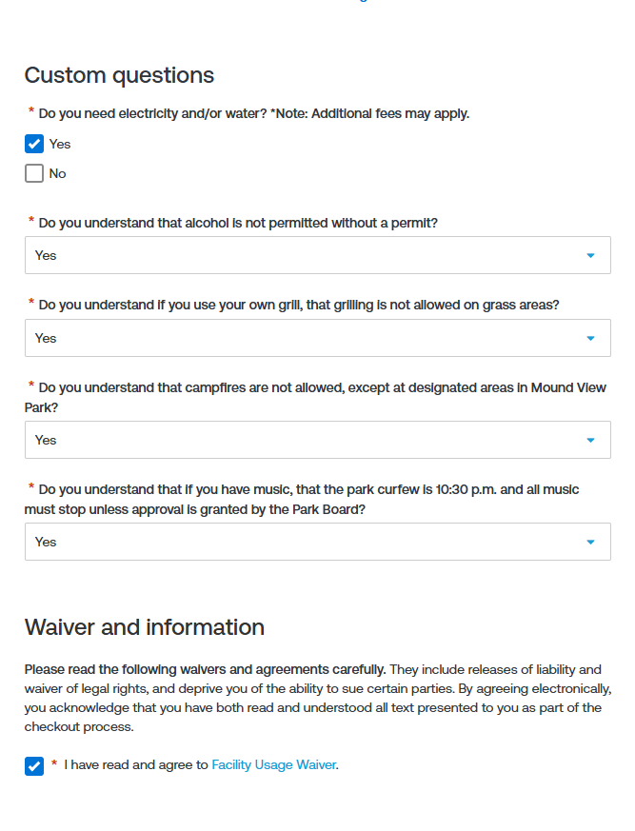
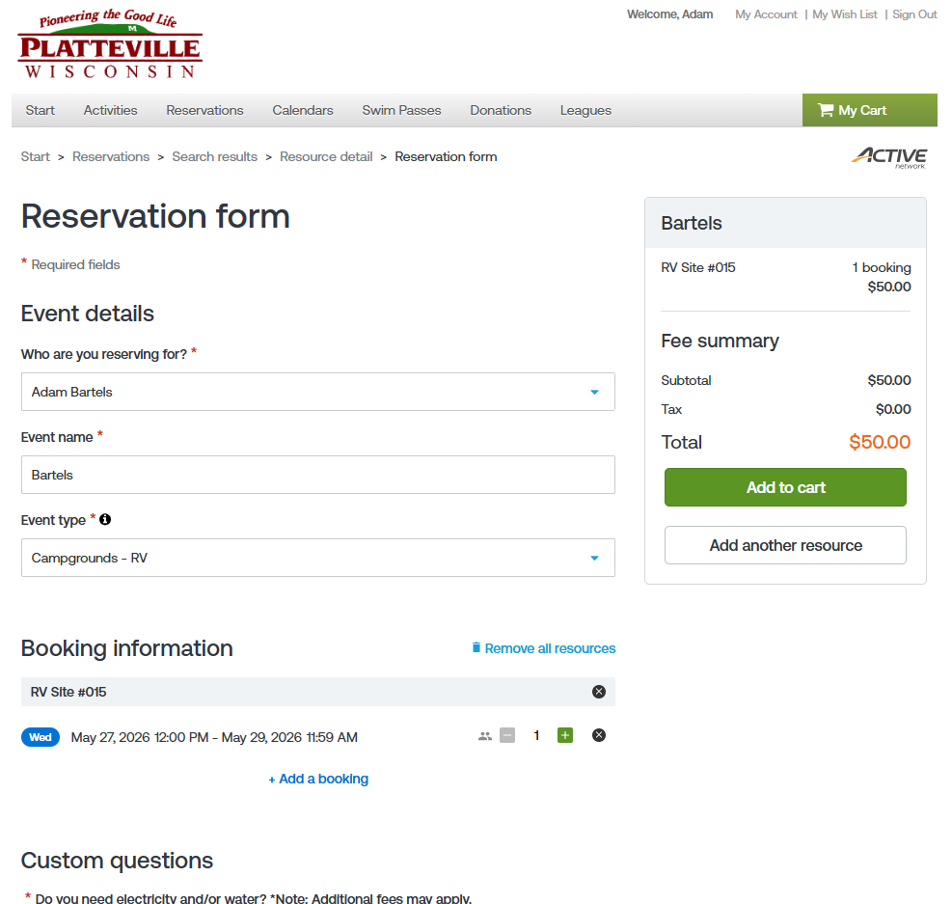

Once you answer all custom questions and agree to the waiver, add your reservation to your cart! (see below)
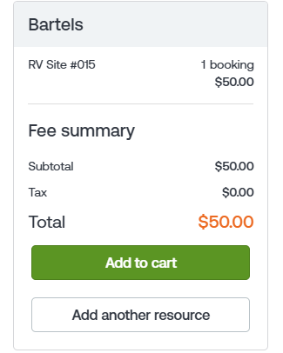
Please agree to the second waiver, then you may check out! (see below) NOTE: Booking online does add convenience fees!
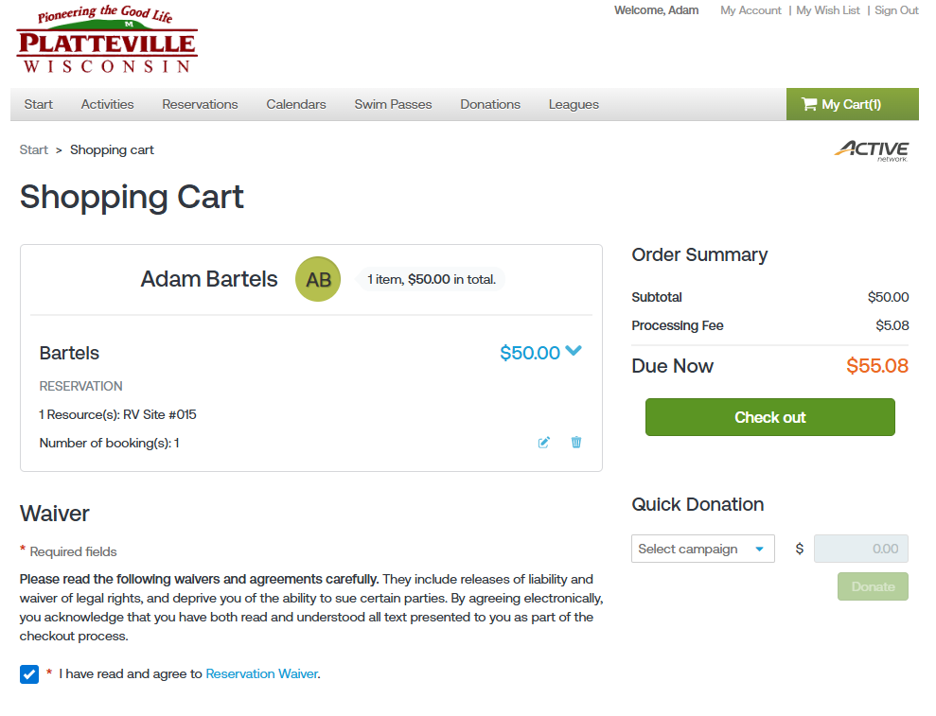

Add your card information and you are all set! Once your card is accepted, you will receive a confirmation email for your booking and you will be set!

If you have any questions or concerns regarding online bookings, please contact the Platteville parks department. Office hours: 8am-4:30pm (Mon-Fri) – Emergency phone: 608-778-4744

