Donor Recognition And Benefits

Recognition Categories - Namings
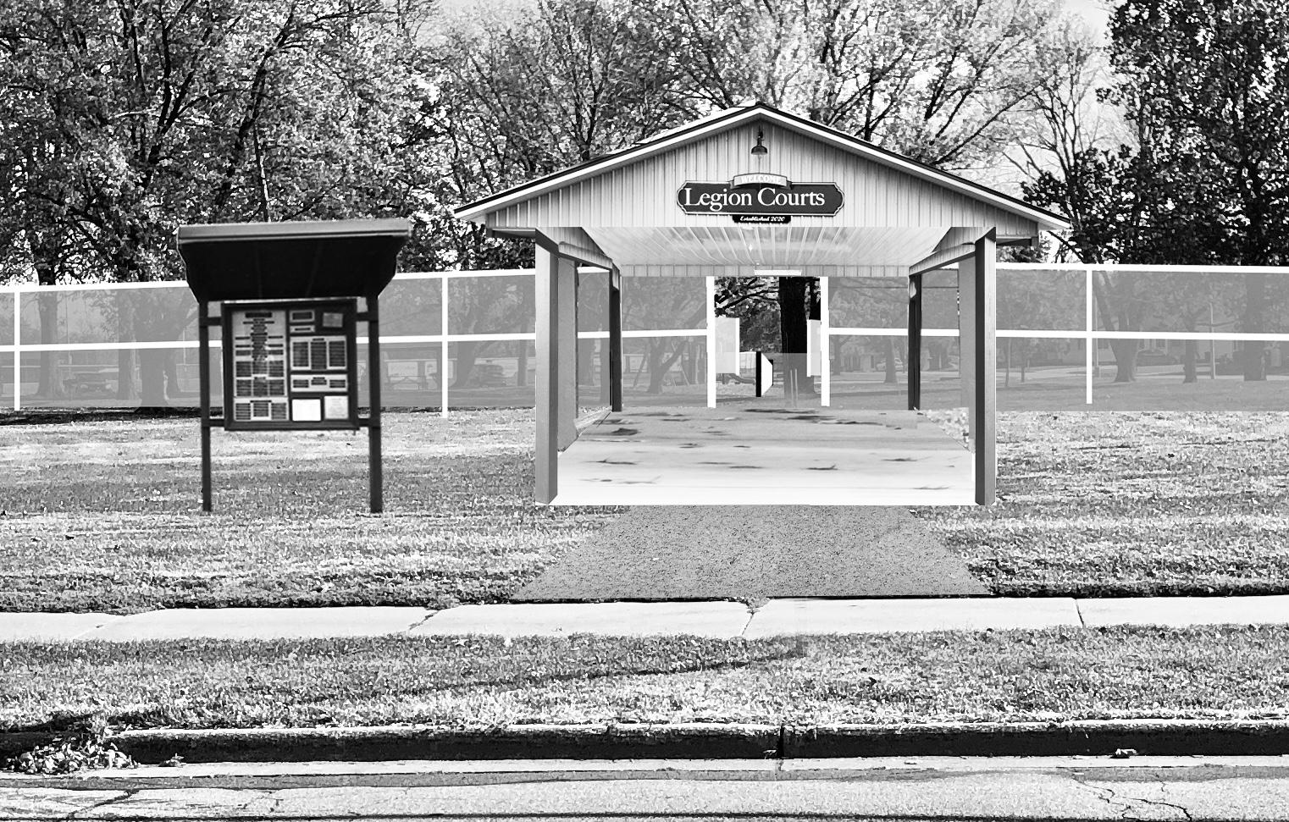
1 - Pickleball Complex: $50,000
Permanent sign at entrance to patio
Name(s) on top of list in donor kiosk
Press Release

1 - Patio: $30,000
Permanent sign inside patio
Name(s) second on list in donor kiosk
Press Release

8 - Court: $16,000 Half Court: $8,000
Permanent sign posted at court
Name(s) in “Courts” section in donor kiosk
Press Release

Recognition Giving Levels

Gold Level: $10,000 +
Name(s) in “Gold” section in donor kiosk listed alphabetically
Press Release

Silver Level: $5,000 - $9,999
Name(s) in “Silver” section in donor kiosk listed alphabetically
Press Release

Bronze Level: $1,500 - $4,999
Name(s) in “Bronze” section in donor kiosk listed alphabetically
Press Release

$1,499 and below
Names listed alphabetical in donor kiosk

PAPA 2020

